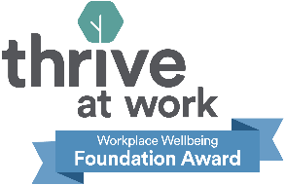
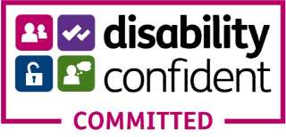

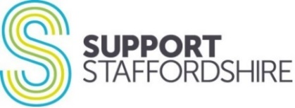

Senior Development Consultant - Job Description and Person Specification

Job Title: Senior Development Consultant

Salary: £29,500 per annum

Hours: 37 hours per week

Contract: Permanent

Location: Stafford Office, with office & home working, within a flexitime contract

Line Manager: Head of Operations Southwest Staffordshire & Consultancy

Line Management of: Training Officers and Sessional Development Consultants

Budget/Income: Earned income targets & discretionary pricing authority

Enhanced Disclosure Required: No
Barred List Check Required (regulated activity only): No

The person appointed will require, proof of right to work in the UK and two satisfactory references.

Job Overview: The post holder is responsible for developing and delivering consultancy and training services, working with their team. Services are delivered on a commercial basis with earned income targets for this team and a growth outlook.

Key Responsibilities:

- The day-to-day management of a team of consultants and trainers, alongside developing a wide range of relationships with commissioners, stakeholders and clients across the County. This work will include delivering against specific component pieces of work, of larger public sector contracts.

- Both delivering consultancy directly and overseeing the team to deliver IAG based on customer requirements on a commercial basis; including but not limited to strategic meeting facilitation, coaching, mentoring and high quality, organisational and personal development, acting as lead/facilitator for external forums, planning and delivering learning events, workshops & conferences, undertaking feasibility studies, governance and policy reviews, charity and company registrations and legal form conversions.
- Working collaboratively with the Operations Manager to implement critical case management systems and processes, including effective caseload allocations across your team forward capacity management, and to ensure income targets are on track and deadlines met.
- Work collaboratively with Communications & Marketing colleagues to ensure effective promotion of products and services; and gathering of stories and testimonials to demonstrate our impact to relevant stakeholders.
- Work collaboratively with the Consultancy Assistant to ensure timely and effective administration, in particular planning and evaluating feedback from customers to ensure
continuous improvement of provision

- Working collaboratively with wider Support & Development colleagues to ensure free to member services and commercial consultancy are complimentary

- Ensuring Support Staffordshire services are consistent with our stated values.
- Ensuring effective cross-organisation working in order to meet our aims and objectives.

- To undertake any other duties as determined by the line manager.

Person Specification: Senior Development Consultant

Some studies suggest that whilst white men apply for jobs when they meet only some of the criteria, women and other minoritized groups only apply when they meet all or almost all criteria. We don’t expect you to have everything we are asking for. We encourage all candidates to consider the range of transferable skills and experience they have, as well as your commitment to learn and develop new skills and knowledge once in the role.

- Able to demonstrate Key Skills required of all Support Staffordshire staff

- Positive work ethic, dependable and conscientious
- Flexibility, use of initiative and good time management
- Collaborative and outcome focussed
- Working to plans, policies & procedures
- Applies equality of opportunity
- Proactive in personal development
- Able to demonstrate Key Leadership & Management Skills
- Building and sustaining effective working relationships
- Bold and creative within risk management and governance frameworks
- Pro-active and outcome focussed approach to problem solving
- Performance management based on support, coaching and enabling

- Excellent and engaging communicator, able to explain and explore complex issues with clarity and purpose, engaging the audience in critical thinking. Adult Education and Training (AET) qualification (or equivalent eg. PTTLLS) desirable; or willing to undertake. Able to engage at all levels, from frontline workers to senior management and board of trustees

- Knowledge of VCSE support and development including funding advice, policies and procedures, safeguarding, personal/organisational development, volunteer management, governance and similar subject matters; willing to broaden own knowledge, fill gaps, and learn on the job as customer demand dictates.

- Highly organised, systems thinker, able to manage multiple strands of work simultaneously, balancing priorities effectively

- Able to undertake research, develop a proposal and pitch for work in a competitive environment, whilst also ensuring projects can be delivered on budget and within agreed timescales.

- Skills in IT/databases for monitoring and effective and efficient in generating outputs and outcomes data for reporting purposes.

- Willing and able to travel across the county with own transport or public transport.

