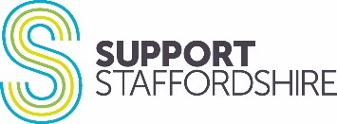
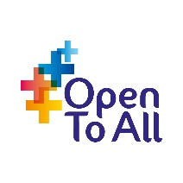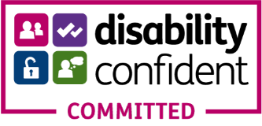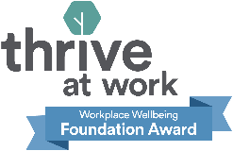

Digital Marketing Assistant
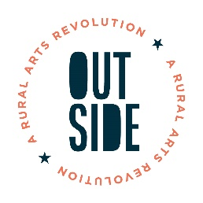
Fixed term to 31st March 2026
22.5 hours a week
£24,000 pro rata (actual salary £14,595 per annum)
Main base Leek with travel and partial home working

OUTSIDE is an Arts Council England Creative People and Places project, with an ambition to ensure everyone in the Staffordshire Moorlands has the opportunity to live a creative life and participate in high quality arts and cultural activity.

We are looking for a creative, organised and enthusiastic individual to join our team and support with the marketing and communication of our programme of arts and cultural activity.

As OUTSIDE Digital Marketing Assistant you will help to communicate all of our projects, activities and events to a wide range of audiences. The varied role will include designing and producing marketing materials, updating our social media channels and website, documenting our projects by capturing photo, video and audio content.

Support Staffordshire is working hard to become more inclusive of the communities we serve, and as such is especially keen to hear from applicants with protected characteristics and lived experience, that bring knowledge, skills and experience which we lack

We welcome an informal conversation in the first instance; please email katie.aldous@outsidearts.org

In order to be considered for this position, you will need to complete an Application Form and Equity, Diversity and Inclusion Monitoring Form. These can be found in the link below, along with the job description and person specification.

The person appointed will require,
Proof of right to work in the UK
Two satisfactory references

Closing date: Friday 10th May @9am
Interview date: Friday 17th May

