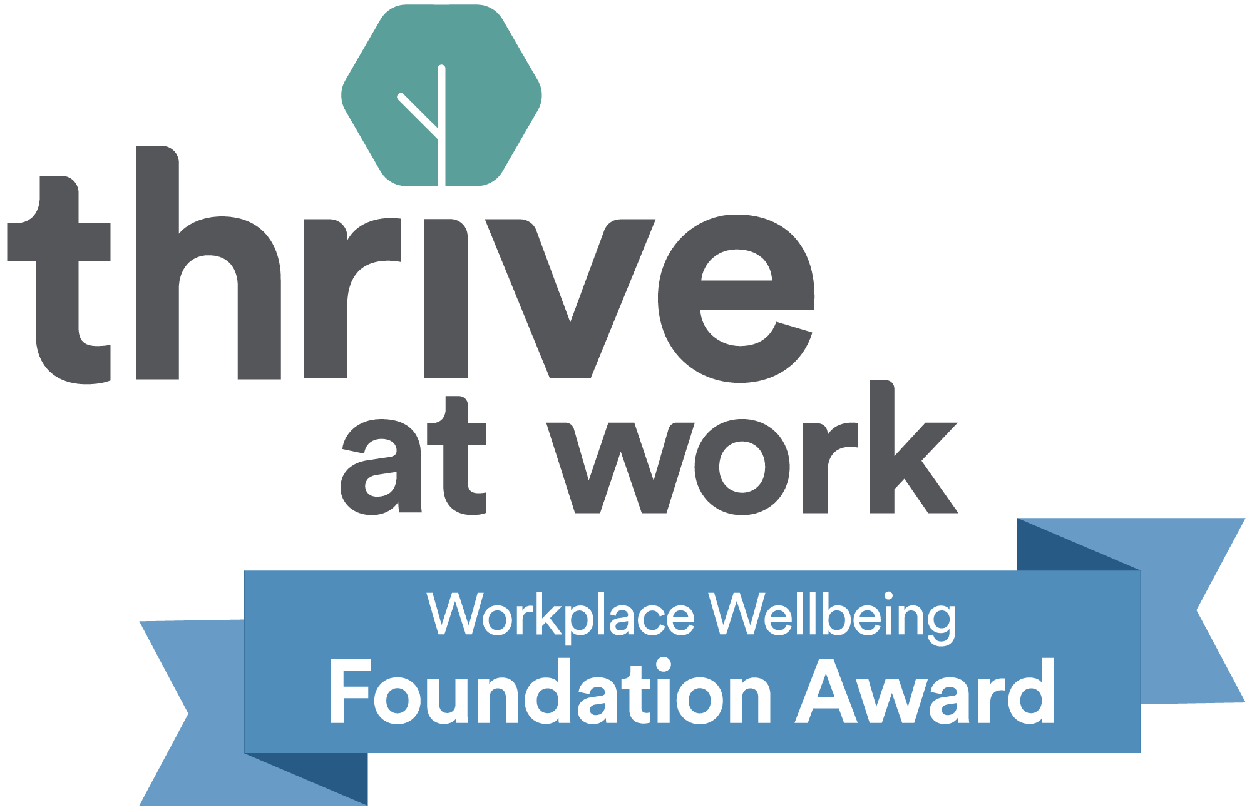

Job Application Form
Application Reference | 2024-01 | Add candidate no
Post/s | Digital Marketing Assistant
Closing Date | 9am 10/5/24
Interview Date | 17/5/24
Please return by email to | recruitment@supportstaffordshire.org.uk
*PLEASE RETURN AS A WORD DOCUMENT*

Personal details
Name
Address
Contact Email
Contact Phone No.
How do you want us to address you? (pronouns)
Eg. he/him, she/her, they/them

When will you be available to start this role if successful?

If you have been convicted of any criminal offence which is not spent, as defined by the rehabilitation of offenders act 1974, please give details

Referee details

Please provide details of two referees, the first of which should be your current or most recent employer (or education provider if this would be your first job).

The second could be a previous employer, education, volunteering provider or other character reference, but should not be a friend, relative or someone you live with.
If you are struggling to think of two referees for a good reason, please tick this box, and we will discuss options, after interviews
Referee One - Name
Organisation
Role in Organisation
Address
Contact Email
Contact Telephone Number/s
Capacity in which known
Can we contact the referee prior to offering you employment?

Referee Two - Name
Organisation
Role in Organisation
Address
Contact Email
Contact Telephone Number/s
Capacity in which known
Can we contact the referee prior to offering you employment?
- Our reach
Where did you find out about this vacancy?
Is there anything we could do to support you to be at your best should we offer you an interview?
This could include reasonable adjustments for disability, neurodiversity, or something else
- Declaration
I declare that the information on this form is true and correct to the best of my knowledge. I understand that if it is subsequently discovered that any statement is false or misleading, my employment may be ended without notice. I understand and agree that data collected in this application form will be used and processed for recruitment purposes. I understand and agree that should I become employed the information will also be used for employment purposes. I agree to you holding and processing this information. By submitting this form by email I am agreeing to this declaration.
Please insert your name
Date
Sections A-D will be detached before short-listing takes place

Application Reference | 2024-01 | Add candidate no

Current and Previous Employment and Work Experience

Please provide details of your current and recent employment (at least the last 5 years) plus any other relevant work experience or volunteering history.
Organisation | Role (state if employed or voluntary and salary where applicable) | Period employed (years & months) | Reason for leaving

- Education and Training

Please list any formal education or professional development training courses which you consider to be relevant to the post (please only give dates where relevant to the qualification eg. where it expires or requires renewal).

Qualification/Training Course and provider where relevant

Person Specification

The person specification sets out the key areas of knowledge, skill and experience required for the post.

This includes ‘Key Skills’ for all staff. Please address the list of key skills together under answer ‘1’ below.

For the remaining items please take each point in turn, writing below how your experience, education, training and qualifications meet each point, giving relevant examples.
Some studies suggest that whilst white men apply for jobs when they meet only some of the criteria, women and other minoritized groups only apply when they meet all or almost all criteria. We don’t expect you to have everything we are asking for. We encourage all candidates to consider the range of transferable skills and experience they have, as well as your commitment to learn and develop new skills and knowledge once in the role.

Use the person specification headings as the headings for each answer below.

Please keep your answers focused and succinct, to no more than 3 pages total.
1 | Positive work ethic, dependable and conscientious
2 | Flexibility, use of initiative and good time management
3 | Collaborative and outcome focused.
4 | Working to plans, policies & procedures
5 | Applies equality of opportunity
6 | Proactive in personal development
7 | Articulate, with excellent written and verbal communication skills
8 | Demonstrable success in delivering social media campaigns
9 | Graphic design experience and/or skills
10 | Experience of using a range of both Adobe and Microsoft Office packages
11 | Experience of WordPress or equivalent web content management systems
12 | Experience of Mailchimp or equivalent email platforms
13 | Good eye for detail
14 | Good team player, work well under pressure and to deadlines
15 | A passion for and commitment to the arts and the community and voluntary sector
16 | An approachable, personable, and clear communicator
17 | Willingness to work evenings and weekends on occasion, and able to travel independently within a rural district.

Any Other Comments

Please add any other comments that you might have in support of your application (this is not a requirement)

