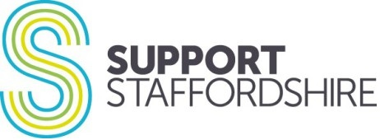

Equity, Diversity and Inclusion Monitoring

Application Reference | 2024-06 | Add candidate no
Post/s | Community Connector - Staying Well and SWITCH
Support Staffordshire is working hard to become more inclusive of the communities we serve, and is especially keen to hear from applicants with protected characteristics and lived experience, that bring knowledge, skills and experience which we lack.
To help us periodically assess our progress against this ambition, we ask all candidates to complete this monitoring form when they apply for a job with us.

We promise that this form will not be viewed or used by anyone involved in your recruitment process. It will only be used to populate anonymous statistics.

We then track, anonymously, overall proportions of candidates who get short-listed, and offered jobs, to check if unintentional bias is adversely affecting our workforce recruitment; and to take positive action for equity if it is.

Please help us to become more diverse by completing as much of this form as you feel able. We have changed this form to use open text boxes, rather than predetermined tick boxes, so that you can tell us how you identify in your own words.

- How do you describe your race or ethnicity?
- How do you describe your gender identity?
If you feel able, please let us know if your gender identity has changed, as this helps us to assess how inclusive we are of transgender people:

- How do you describe your sexuality or sexual orientation?
Eg. bisexual, gay, straight etc.:

- Are you married or in a civil partnership?
- Are you or have you recently been pregnant, given birth, taken maternity/paternity or adoption leave, or suffered a miscarriage?
Here we are interested in assessing for any bias linked to maternity leave, parenting commitments etc.:

- Do you consider yourself to be disabled, have an impairment or have a long-term health condition?
We usually operate in accordance with the social model of disability; that it is social barriers which cause a person to be disabled, not the person themselves. We would encourage you to be as open as you can about disability, so that we can strive to be more inclusive and remove barriers that we may be responsible for.
The Equality Act 2010 defines a disability as: a physical or mental impairment which has substantial and long-term (lasting more than 12 months) adverse effect on your day to day living. We want to know your own view even if it does not obviously meet this definition:

- How do you describe your religion or lack of religion?
- How old will you be on the closing date for this job?

Thank you for helping us to be more inclusive! Please return with your application to recruitment@supportstaffordshire.org.uk as a Word document.

