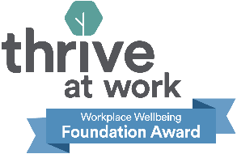

Job Description and Person Specification

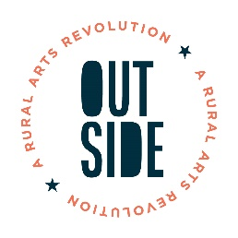
Job title: Digital Marketing Assistant

Salary: £24,000 (pro rata) £14,595 (Actual)
Hours: 22.5 hours per week

Contract: Temporary (Currently funded until March 31st 2026
Location: Leek Staffordshire Moorlands

Line Manager: OUTSIDE Operations Manager

The person appointed will require, proof of right to work in the UK and two satisfactory references.

Job Overview:
OUTSIDE is an Arts Council England Creative People and Places project, with an ambition to ensure everyone in the Staffordshire Moorlands has the opportunity to live a creative life and participate in high quality arts and cultural activity.

We are looking for a creative, organised and enthusiastic individual to join our team and support with the marketing, communication and evaluation of our programme of arts and cultural activity.

As OUTSIDE Digital Marketing Assistant you will help to communicate all of our projects, activities and events to a wide range of audiences. The varied role will include designing and producing marketing materials, updating our social media channels and website, documenting our projects by capturing photo, video and audio content.

Key Responsibilities:

1. Ensuring Support Staffordshire services are consistent with our stated values.
2. Ensuring where appropriate, that volunteers are involved in delivering our services.
3. Ensuring effective cross-organisation working in order to meet our aims and objectives.
4. Prepare content for multiple channels including website, newsletter, social media, press
5. Update information on the OUTSIDE website and other online platforms
6. Use relevant channels to market to different groups of people, from face-to-face relationship building, to social media campaigns, to posters, flyers and PR
7. Manage and update information and engage with communities on social media channels including Facebook, Instagram, Twitter/X, LinkedIn and TikTok.
8. Contribute to and distribute e-newsletters, manage subscribers.
9. Design and produce marketing materials including graphics for social media, posters and flyers
10. Distribute printed materials in local area
11. Capture our events and activities via photo, video and audio content
12. Maintain asset library of images, video, graphics and other marketing materials
13. Ensure that marketing materials and communications are accessible to all.
14. To undertake any other duties as determined by the line manager.

Person Specification:

Some studies suggest that whilst white men apply for jobs when they meet only some of the criteria, women and other minoritized groups only apply when they meet all or almost all criteria. We don’t expect you to have everything we are asking for. We encourage all candidates to consider the range of transferable skills and experience they have, as well as your commitment to learn and develop new skills and knowledge once in the role.

- Able to demonstrate Key Skills required of all Support Staffordshire staff

- Positive work ethic, dependable and conscientious
- Flexibility, use of initiative and good time management
- Collaborative and outcome focused.
- Working to plans, policies & procedures
- Applies equality of opportunity
- Proactive in personal development
• Articulate, with excellent written and verbal communication skills
• Demonstrable success in delivering social media campaigns
• Graphic design experience and/or skills
• Experience of using a range of both Adobe and Microsoft Office packages
• Experience of WordPress or equivalent web content management systems
• Experience of Mailchimp or equivalent email platforms
• Good eye for detail
• Good team player, work well under pressure and to deadlines
• A passion for and commitment to the arts and the community and voluntary sector
• An approachable, personable and clear communicator
• Willingness to work evenings and weekends on occasion, and able to travel independently within a rural district.

