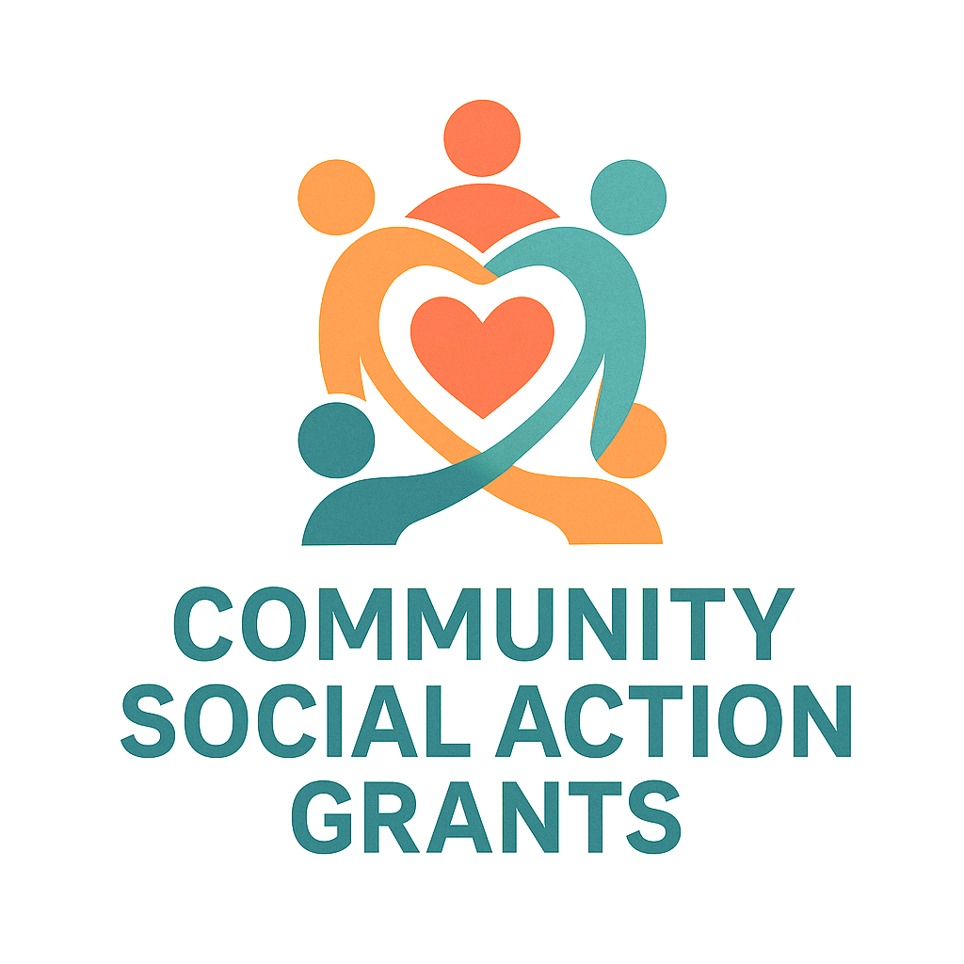



STAFFORDSHIRE MOORLANDS COMMUNITY SOCIAL ACTION GRANT - DRAFT
Guidance for Applicants

What is this fund?
Support Staffordshire is delivering the Community Social Action Grant funded by the UK Government’s UK Shared Prosperity Fund on behalf of Staffordshire Moorlands District Council. This fund is designed to help grassroots organisations run small community activities or projects that bring people together and lead to improved community cohesion.
Whether it’s a one-off activity or a short-term activity, the aim is to strengthen neighbourhood ties, reduce social isolation, and promote community action through volunteering. These activities should lead to outcomes that stimulate future opportunities for communities or groups, such as a day event, workshop, or community project.
This guidance outlines who can apply, the types of activities eligible for funding, and the process for submitting your application. All applications must be submitted using the official application form, and certain supporting documents are required.
The first round of funding is available during the financial year 2025/26:
- Round One deadline: Friday, 18th July 2025. (Midnight)
If funds remain, a second round may be announced—please check the Support Staffordshire website for updates.

Who can apply?
You can apply if your group is:
- A voluntary or community group with a simple constitution
- A registered charity
- A CIC (Community Interest Company)
- A CIO (Charitable Incorporated Organisation)
- A new group (even if not yet formally constituted – but willing to adopt a simple policy)
- A Parish Council on behalf of a new group
AND your activity will benefit people or places within the Staffordshire Moorlands.

Who cannot apply?
- Individuals
- Private businesses
- Groups set up for party-political or religious promotion
If you're unsure about your eligibility, please get in touch for advice.

What can the grant be used for?
You can apply for up to £500 to support the full cost of a project or event, or as match funding with other sources.
Here are some examples of eligible costs:
- Venue hire
- Refreshments
- Promotional materials
- Equipment or materials for a community activity
- Volunteer expenses (e.g., travel)
- Training for volunteers
- Public liability insurance or temporary licences (if needed)
The project must:
- Involve local volunteers
- Be community-led
- Take place within the Staffordshire Moorlands
- Be time-limited (not for ongoing running costs)

We cannot fund:
- Activities that have already happened (retrospective funding)
- Projects with no community benefit
- Activities that are entirely religious or political in nature
- Statutory services or obligations
- Activities that are not involving and benefitting the Staffordshire Moorlands community
- VAT (if you are VAT registered)
Groups may only apply once per funding round.

Planning your activity
Before applying, please consider:
- Do you need insurance, licences, or permissions?
- Have you considered health and safety and safeguarding?
- How will you engage volunteers?
- Will your project leave a lasting benefit for the community?
- Can you clearly show how your project will bring people together?

How to apply
Applications must be submitted using the Community Social Action Grant application form.
Send completed forms to:
Ryn.hughes@supportstaffordshire.org.uk

Required documents
Please include the following with your application:
- A signed and dated constitution (if applicable)
- Your most recent accounts OR a bank letter confirming your group’s name and account number (for new groups)
- Safeguarding policies (if applicable)
- Any permissions or licences (if applicable)
- Any additional information that helps explain your project

If you are successful
You’ll receive a Grant Offer Letter and a Conditions of Grant agreement. Funds will be paid directly into your group’s bank account.

Monitoring and reporting
After your event or project, you will need to complete a brief report detailing how the funds were used and the impact made. Please include:
- A breakdown of expenditure
- How many people attended or were involved
- Photos, feedback, or publicity (where available)
Some of your evidence may be used by Staffordshire Moorlands District Council to celebrate the success of the scheme.

Need support?
For advice or help with your application, contact:
Ryn.hughes@supportstaffordshire.org.uk
07395365948
Support Staffordshire can also help your group with:
- Other funding opportunities
- Good governance and policy development
- Community news and networking
Visit: www.supportstaffordshire.org.uk

